1. write and run the programs using notepad and cmd   
2. submit your .java code along with screenshot of output   
3. do not submit rar/zip file  
4. current path of cmd must include your roll no

## Task - 01:

Define a class to represent a student. Include the following members

**Data Members (all attributes must be private)**

Name of the student

ID number

Department name

Six Subjects

Marks obtained

Total marks

**Member Function**

Write setter and getter property to set all attributes

To calculate percentage and grade

To display name and ID number, percentage and grade

Note: You must ask the user to input the values

## Task - 02:

Create a class **Teacher** with the following **private** attributes:

* Name
* Age
* Institute

Derive three classes from it that has the following names: **HumanitiesTeacher, ScienceTeacher, MathsTeacher**

These classes should have the following members:

* Field (this should have the value “science”, “maths” or “humanities”)
* Course Name
* Designation (for example, lecturer, professor, etc)

Create proper accessors and mutators for the attributes.

Create objects for each of the classes and display the values. You must ask the user to input the values

## Task - 03:

A defense organization is making an hierarchy of different types of weapons. They have classified the nuclear bomb as follows:

Weapons → Hot Weapons → Bombs → Nuclear Bombs

Create classes and apply inheritance as necessary for the above hierarchy.

Each class should have a method called: “xxxxxDescription”, where xxxx would be class name.

The method should print out what that weapon does. Eg. Hot weapons uses gunpowder, or explode. Bombs blow up. Nuclear bombs blow up, and use nuclear fission and fusion.

## Task - 04:

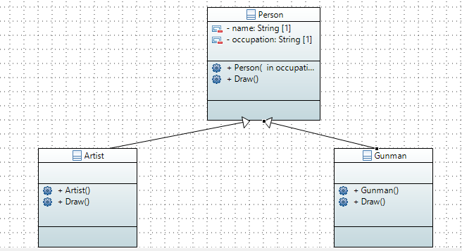

Create the classes following the diagram shown. Keep the following things in mind:

* When an object of Artist is created, the value “artist” will be set to occupation.
* When an object of Gunman is created, the value “gunman” will be set to occupation.
* Person::Draw() will print out “A person can draw in many ways”
* Artist::Draw() will print out “An artist can draw with a paint brush”
* Gunman::Draw() will print out “A gunman draws a gun to shoot”